IS 5203 Lab #1 Mininet VLAN
[Your Name]
Submission Instruction:
- Save the file in .pdf format (Must be in PDF format, other formats including .doc will not be graded) with your name on the top of the document and upload to the Blackboard item where you downloaded this instruction.
Lab objectives:
- Customize network topology
  - Scripts
  - Miniedit.py
- Configure Open Switch settings
- Observe VLAN communications (access port, trunk) using Wireshark
Before you start, please note the commands in this lab will be executed in different terminals, each will use a different command prompt:
- Command prompt “$” indicates that the command is executed at the Linux system level.
- Command prompt “>” indicates that the command is executed in the Mininet CLI (i.e., after you run Mininet with “sudo mn” or with MiniEdit).
- Command prompt “#” indicates that the command is executed in the terminal of a simulated device (e.g., the Mininet simulated host/switch).
For all commands, please check for spaces between arguments, letter cases, and typos before you execute them.

Customize VLAN Topology with Python Scripts (Simulation 1: Access Port) (25 pts)
We will simulate a VLAN configuration on the following topology.
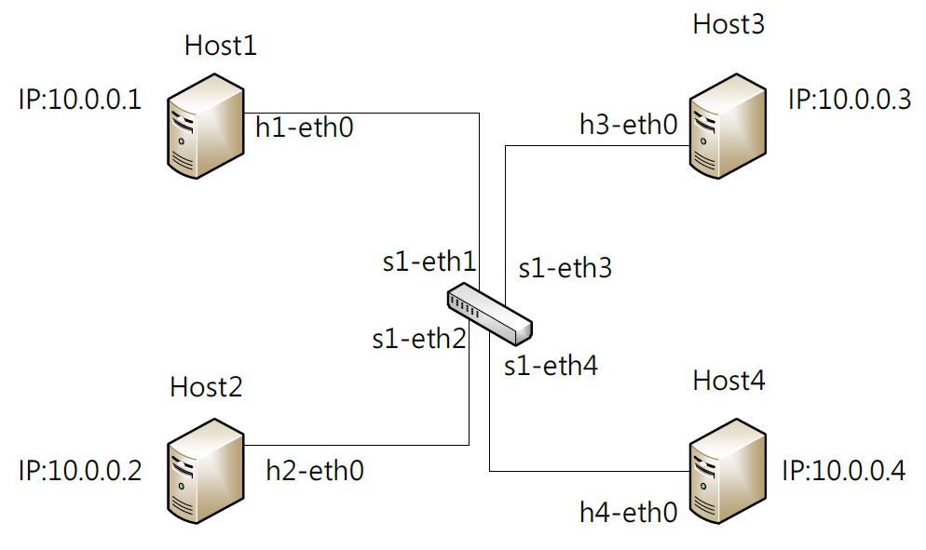
Figure 1. VLAN Topology 1.
1. Launch and login to your VM. Pull up a terminal window (Ctrl+Alt+T).
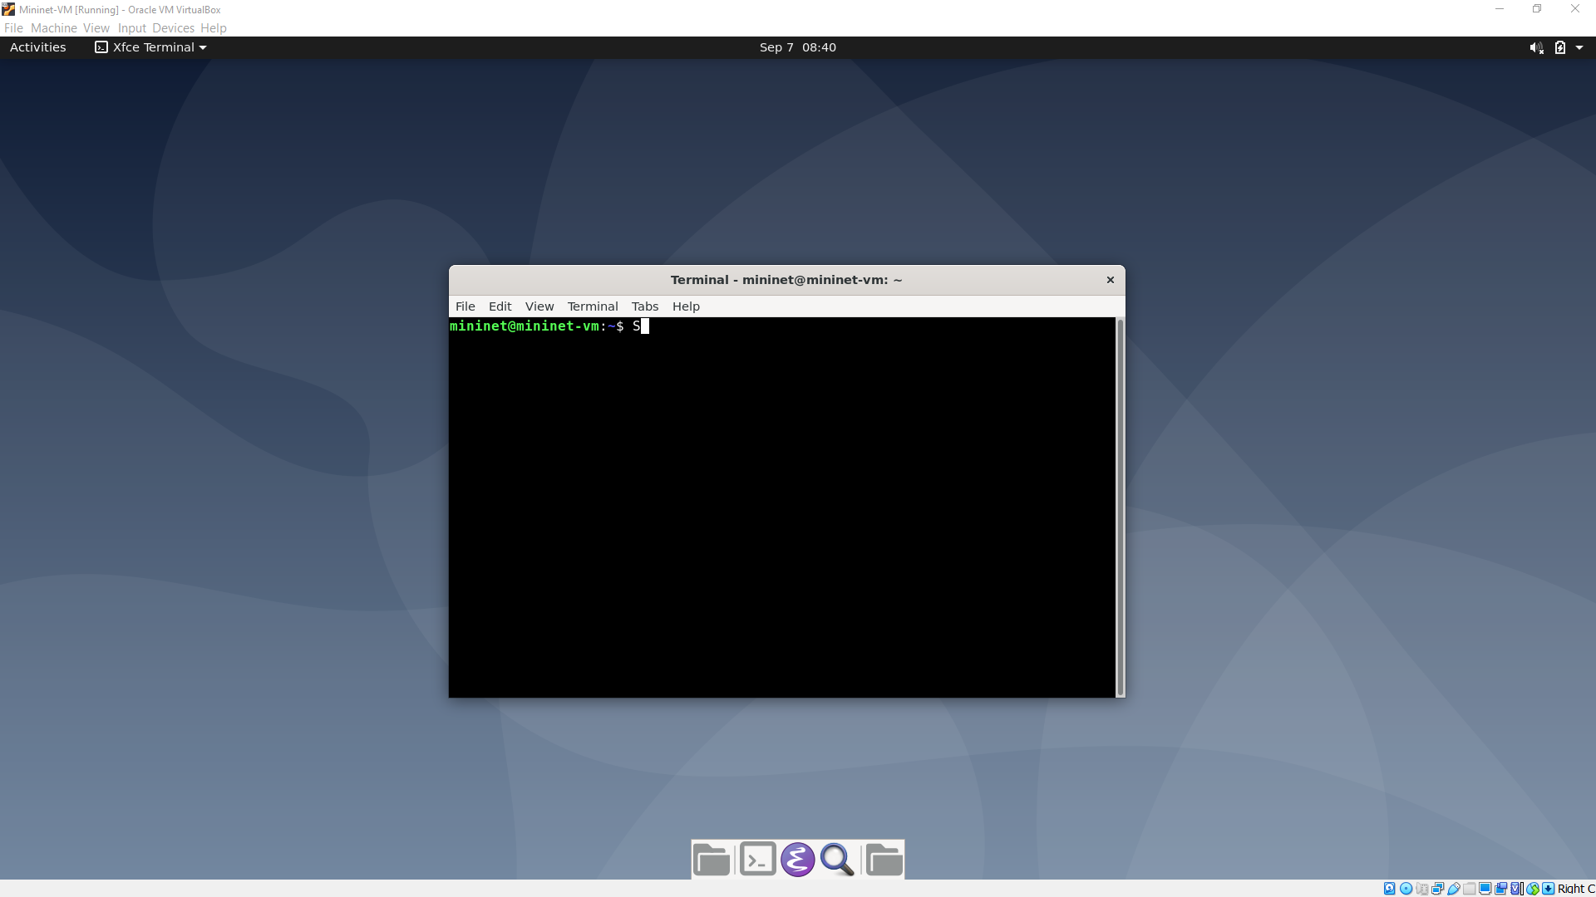
We will modify a custom topology file under ~/mininet/custom.
$ cd ~/mininet/custom
$ ls -l
You will find the topo-2sw-2host.py file, which we will build our topology upon. Duplicate and rename the topology file to topo-1sw-4host.py with the following command.
$ cp topo-2sw-2host.py topo-1sw-4host.py
And use editor to modify the file (below I use “nano,” you can also use GUI text editor “emacs” to edit the new file with “$ emacs topo-1sw-4host.py”).
$ nano topo-1sw-4host.py
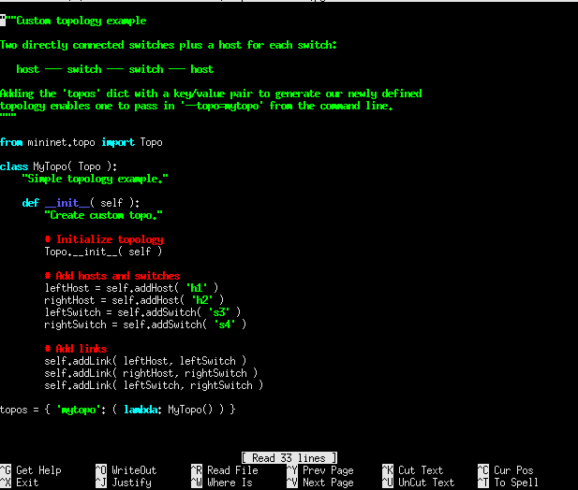
The original script used self.addHost( ‘hostname’ ) and self.addSwitch( ‘switchname’ ) to create network devices in the topology. These devices should have different variable names. Then, self.addLink( deviceA, deviceB ) connects two devices, where deviceA and device are variable names of the two devices.
For instance, the example topology is:
host --- switch --- switch --- host
So in the definition script, it defines four variables (leftHost, rightHost, leftSwitch, rightSwitch), each denotes a device. The name of the host on the left is “h1,” the name of the switch on the left is “s3,” so on so forth.
Then, in the definition script, it add links between the defined devices to connect them. For example,
self.addLink(leftHost, leftSwitch)
connects leftHost (“h1”) and leftSwitch (“s3”) in the topology.
For more Mininet API support, you can refer to Chapter 18 in our textbook (ver. 1.9.2). You can also find examples on the Mininet official site (http://mininet.org/walkthrough/).

Deliverable #1. (10 pts) Modify the seven lines of topology definition (those below “# Add hosts and switches” and “# Add links”). Define our 1-switch 4-host topology in this file (refer to Figure 1) (9 pts). After you are done, take a screenshot of your edits and paste it below (1 pt). Save the topology file and exit the editor.
Hint 1: After removing the existing definitions, you only need to use self.addHost(), self.addSwitch(), and self.addLink() to define our topology).
Hint 2: The three APIs are case-sensitive. Please double-check to eliminate any topos.
Hint 3: Please use “space” to indent each line of the script properly, following the style of the example script where codes on the same level have the same amount of indentation (i.e., same amount of “spaces” before the command).
Hint 4: Remember to save the edited file. In nano, you can use ^O (Ctrl + O) to save the file and ^X (Ctrl + X) to quit the editor. If you use Emacs, you have GUI logos to save the file and exit the editor.

[Screenshot here]

2. Explore your customized topology.
We then launch the mininet environment and load the customized topology:
$ sudo mn --custom ~/mininet/custom/topo-1sw-4host.py --topo mytopo
Deliverable #2. (10 pts) Please execute the following commands to explore your customized topology:
- nodes
- net
- h1 ping -c 3 h2
- pingall
- h1 ifconfig -a
Attach screenshots for each command (1 pt each) and briefly explain the result of each command (1 pt each) (you can ignore all controller/c0 entries).
[Screenshots here]

3. Configure VLAN ports.
> xterm s1
We remove the controller because we will not use it in this simulation. (Texts after “//” are comments. You don’t need them for execution.)
# ovs-vsctl show // Show openvswitch settings
# ovs-vsctl del-controller s1 // Delete controller
# ovs-vsctl set-fail-mode s1 standalone // Standalone open vSwitches will configure the forwarding/flow table on its own, if set to “secure”, the switches will not add an entry.

VLAN Configs
# ovs-vsctl set port s1-eth1 tag=10 // Set the vlan tag of host1’s corresponding port to 10
# ovs-vsctl set port s1-eth2 tag=20 // Set the vlan tag of host2’s corresponding port to 20
# ovs-vsctl set port s1-eth3 tag=10 // Set the vlan tag of host3’s corresponding port to 10
# ovs-vsctl set port s1-eth4 tag=20 // Set the vlan tag of host4’s corresponding port to 20
Exit xterm on s1
# exit

Deliverable #3. (5 pts) Explore the effect of VLAN.
> pingall
Paste a screenshot of the result (1 pt), briefly explain why packets are dropped.
[Screenshot]

4. Exit Mininet environment and clean up:
> exit
$ sudo mn -c

Customize VLAN Topology with miniedit.py (Simulation 2: Trunk) (25 pts)
Mininet comes with a GUI topology editor. We will use this editor to create our second topology and use Wireshark to observe the communications on a trunk port.
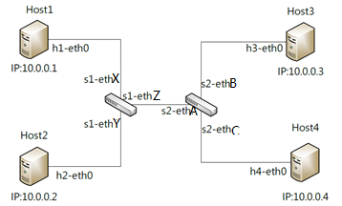
Figure 2. VLAN Topology 2.
1. Launch miniedit
# cd ~
# sudo ~/mininet/examples/miniedit.py
Miniedit is a drag-and-drop GUI for network topology customization. You can refer to http://www.brianlinkletter.com/how-to-use-miniedit-mininets-graphical-user-interface/ for a walkthrough.
2. Create the topology
Drag-and-drop the hosts and switches following their ID sequence (e.g., host1, host2, …). Use links to connect the devices.
Deliverable #4. (5 pts) Paste a screenshot of your topology.
[Screenshot]

Remember to check the “Start CLI” option in Edit – Preferences. Otherwise, you will not be able to interact with the network using the terminal. Hit the “run” button at the bottom left corner to start Mininet with the topology you defined.
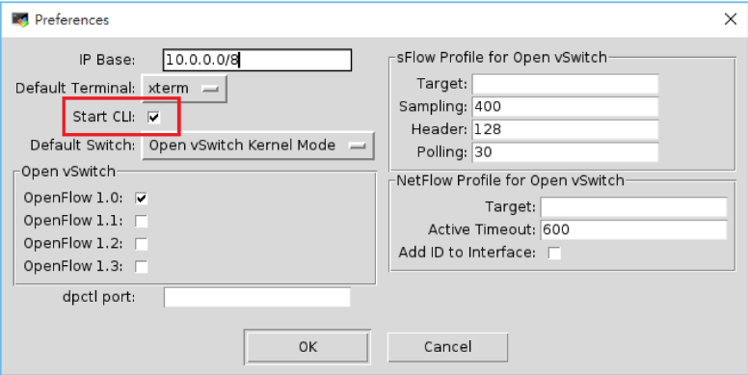
3. Initial testing
Similar to Simulation 1, we configure the switches to run in standalone mode for them to learning forwarding table on their own.
> xterm s1
# ovs-vsctl set-fail-mode s1 standalone
# ovs-vsctl set-fail-mode s2 standalone
Deliverable #5. (5 pts) Execute “pingall” to test connectivity among all hosts. Provide a screenshot of the result below (5 pts).
[Screenshot]

4. VLAN Config
VLAN Configs
Note: When multiple interfaces exist on a device (e.g., a switch), MiniEdit will connect hosts to a random interface. Thus, in the topology diagram, s1-ethX/Y/Z and s2-ethA/B/C may have arbitrary assignments for each student. Run “net” in the Mininet CLI to examine the correct interfaces linking to host1/host2/host3/host4. For example, in the below environment, h1 is connected to s1-eth3; h2 is connected to s1-eth1; h3 is connected to s2-eth1; and h4 is connected to s2-eth2.
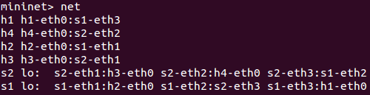
Deliverable #6. (10 pts)
Please paste your “net” result below (2 pts):
[Screenshot]

With this VLAN configuration, we want to achieve two goals:
- When the link between s1 and s2 is down, no devices can connect to each other:
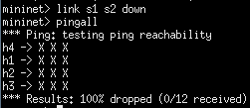
- When the link between s1 and s2 is up, h1/h3 are connected and h2/h4 are connected.
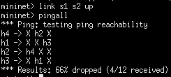
Based on the connection information, please replace the highlighted (red) interfaces names and tags below to correctly configure your network. Imitate the style in the first experiment under “VLAN Configs.” PLEASE REPLACE THEM BASED ON YOUR OWN RESULTS. DO NOT COPY AND RUN THE COMMANDS DIRECTLY (it won’t work).
# ovs-vsctl set port s1-ethX tag=A // Set the vlan tag of the interface linking to host1
# ovs-vsctl set port s1-ethY tag=B // Set the vlan tag of the interface linking to host2
# ovs-vsctl set port s2-ethB tag=C // Set the vlan tag of the interface linking to host3
# ovs-vsctl set port s2-ethC tag=D // Set the vlan tag of the interface linking to host4
Exit xterm on s1
# exit

Two commands to help with your experiments: (USE WHEN NECESSARY. READ THE INTRODUCTION BEFORE MODIFIYING/EXECUTING THE COMMAND).
[VLAN tag query] If you want to know the VLAN tag you configured on an interface (e.g., s1-eth4), you can execute the below command:
# ovs-vsctl get port s1-eth4 tag
[VLAN rule removal] If you want to remove a mistakenly configured rule (e.g., “set port s1-eth4 tag=20”), you can execute the below command:
# ovs-vsctl remove port s1-eth4 tag 20 (Note: no “=” in this command)

Provide a screenshot of your configuration commands (i.e., the four “# ovs-vsctl …” commands) (2 pts)
[Screenshot]

Provide a screenshot of the result after you execute (2 pts):
mininet> link s1 s2 down
mininet> pingall
[Screenshot]

Provide a screenshot of the result after you execute (2 pts):
mininet> link s1 s2 up
mininet> pingall
[Screenshot]

Please briefly analyze/explain why your VLAN configuration can achieve our two goals. (hint: When s1 and s2 is down, are hosts connected locally to the same switch on the same VLAN? When s1 and s2 is up, which hosts can talk with each other?) (2pts)
Answer:

5. Wireshark capture
We will use Wireshark to capture packets on the trunk link (the link between s1-ethZ and S2-ethA in the topology figure. PLEASE REPLACE THE HIGHLIGHTED INTERFACES BASED ON YOUR “NET” RESULT). You can capture on either s1-ethZ or s2-ethA. The below command launches on s1 and monitors s1-ethZ.
> s1 wireshark & (Note: don’t forget this “&” symbol to detach wireshark from the terminal)
Start Wireshark capture on the correct interface.
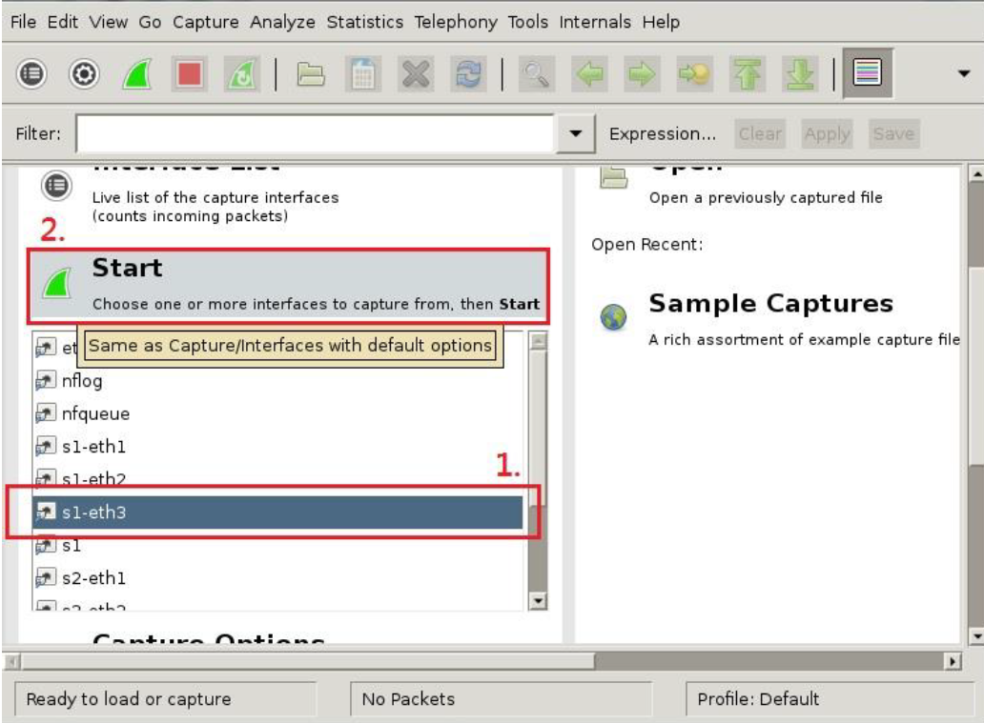

Deliverable #7. (5 pts) Execute “pingall” in the CLI. Paste a screenshot of the packet list after the connectivity test (1 pt). Observe an ICMP packet sent by host1 and host2, what are their corresponding IDs in the 802.1Q protocol? (2 pts) Why we can capture packets for both VLANs on this port? (2 pts)
[Screenshots]

6. Clean up
Exit wireshark.
(mininet CLI)
> exit
(miniedit)
Hit the “stop” button on the bottom left to stop simulation. Save the topology if you want. Exit the GUI editor.
(Linux Terminal)
$ sudo mn -c

